Image | 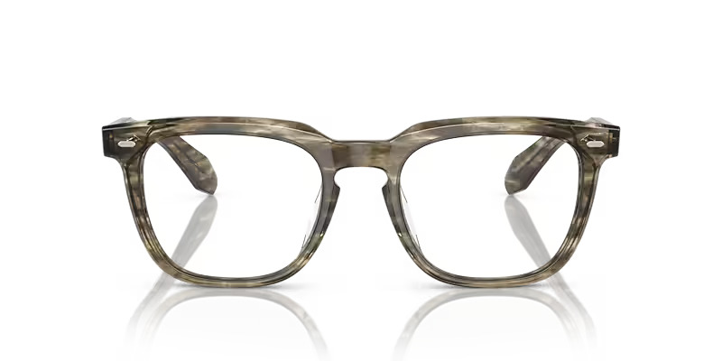
Brand | DIOR
Model Name | N.06
Price | RS 1699
PRODUCT DETAILS

